PHOTOENTRY USER GUIDE by Philip Smithies

When you advise the Competition Organiser that you wish to enter competitions, your name and email address will be entered into PhotoEntry and you will receive an automatically generated standard email which may go to your junk mail.
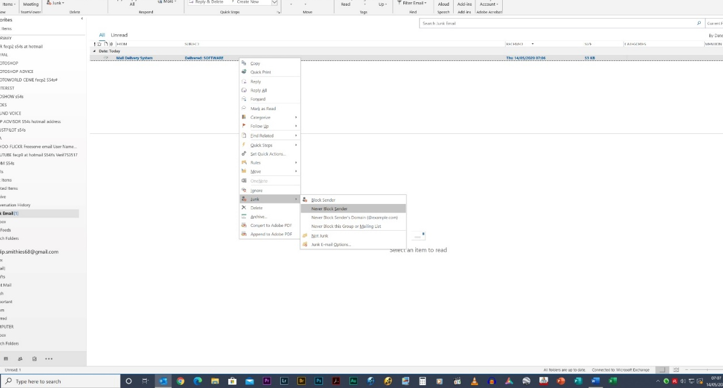
Fig 00
To stop important messages going to junk:
1 right-click on the message
2 in the menu that appears, left-click “Junk” and select the most appropriate option.
3 This usually works for future occasions – but not always. Periodically check your junk emails.
4 Move the email to the normal in-box

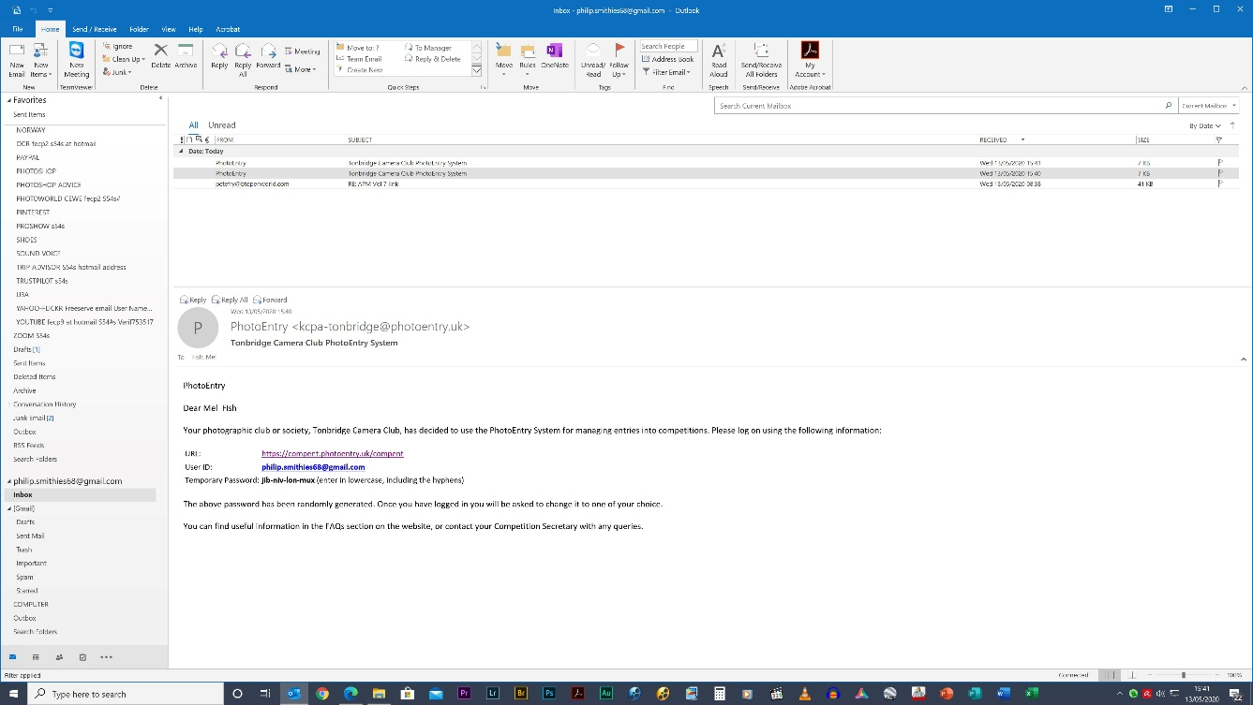
URL
User ID
Temporary Password
Fig 01.
In the email addressed to you (possibly with your last name first depending on how the software is configured), you’ll see a link (URL) to the PhotoEntry site, a User ID (your email address) and a temporary password.
Click on the URL link.
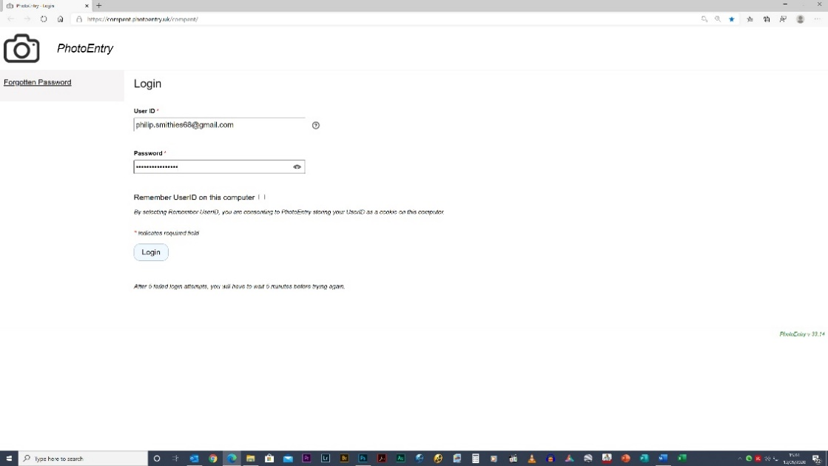
1 On the web-page that appears, the User ID will already be there.
2 Enter your password that was in the email in Fig 01. You can copy and paste it from the email.
3 Tick “Remember User ID on this computer”
4 Click “Login”

Fig 02

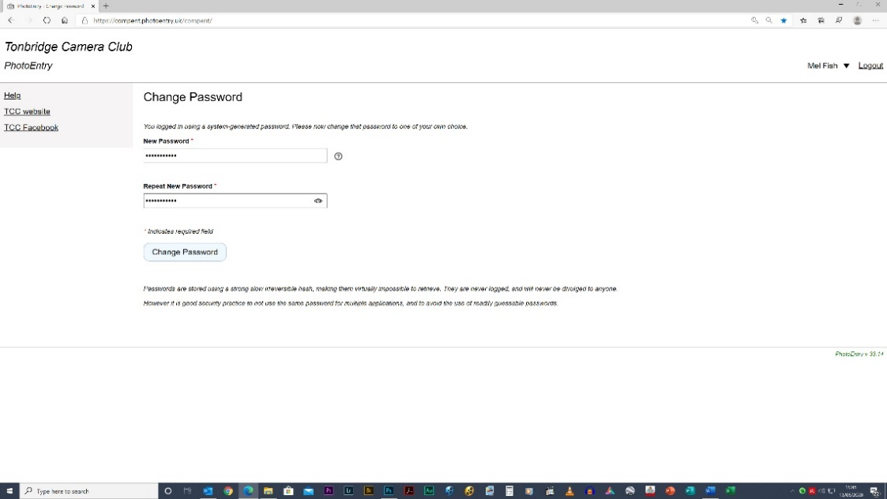
1 Enter a password of your choice
2 Re-enter the password
3 Click “Change Password”

You may be offered the choice of allowing your machine to remember your password.

Fig 03 (this will only appear the first time you use the software)

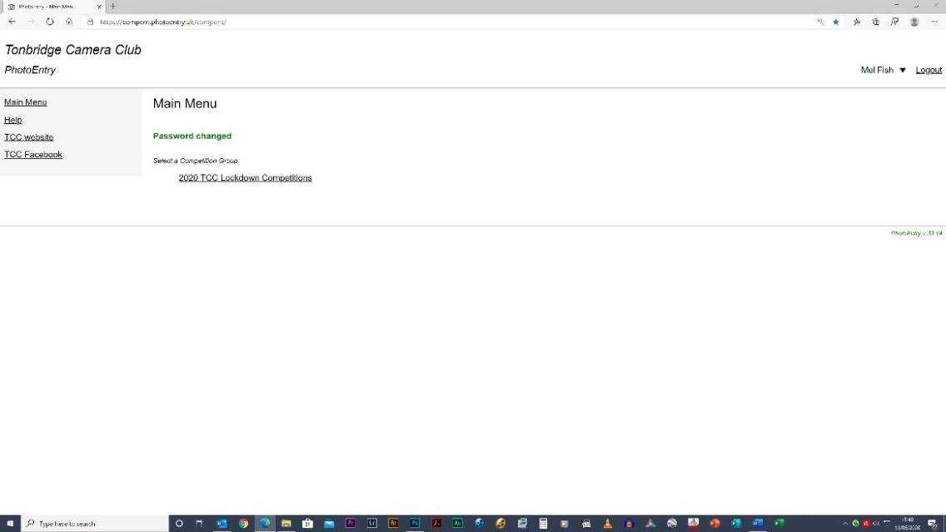
Fig 04
On the left are a number of links including the club’s website and Facebook page.
Navigate to the correct competition (more will be added in due course) and click.
Consider adding the URL to your “Favourites”: https://compent.photoentry.uk/compent/
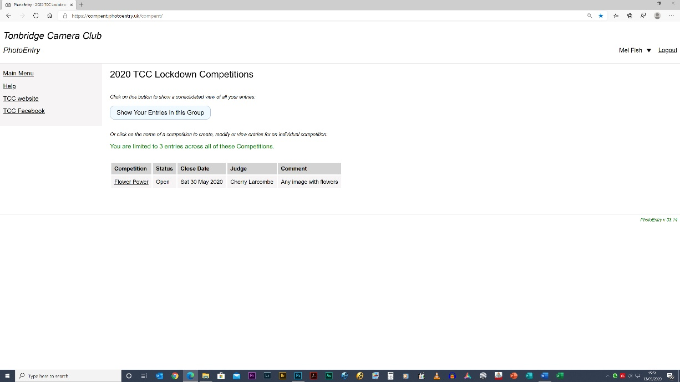
Fig 05
1 Click on the name of the competition. You will only be able to access it if the Status is “Open”
2 When you revisit the page, you can modify your entries here

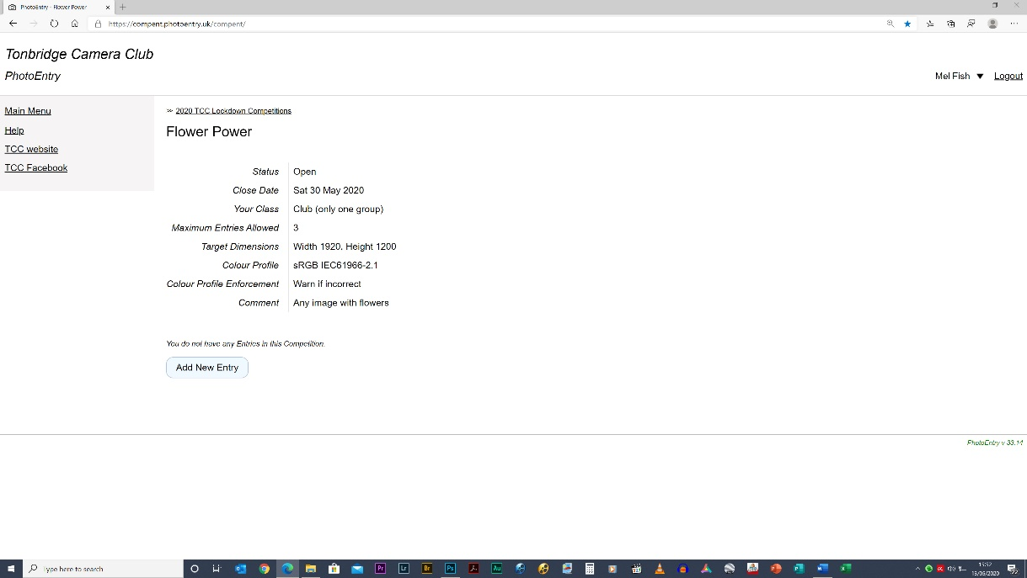
Fig 06
A screen with information about the competition appears.
Click on “Add New Entry”

IMPORTANT NOTE:
Every competition will be configured with the projector’s “Target Dimensions” of 1920 x 1200. I strongly recommend that you resize your images accordingly.

However, it is no longer compulsory to resize your images as PhotoEntry software will do it for you (something which DiCentra doesn’t do). Read Appendix 1 on the final page for more information based on that given in PhotoEntry’s “Help” section

If you want to resize your images but don’t have any photo-editing software, read Appendix 2A (A simple and free way to resize images online without using software) and/or 2B (A simple and free way to resize images using Microsoft’s “Photos” App)

Ways of resizing images using Photoshop are described in detail in the Competition Rules.
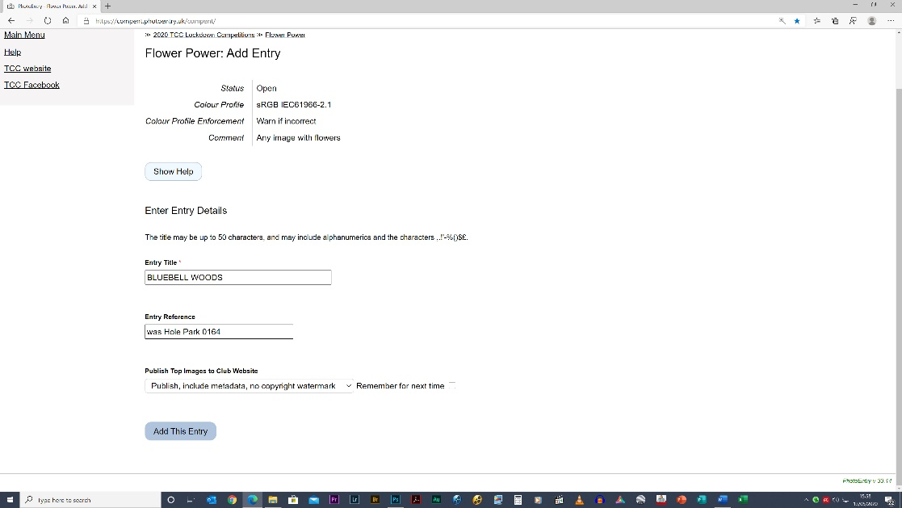
1 Enter the title (UPPER CASE ONLY). DON’T include your name or the word BY.
2 If you want to make brief notes to remind you of something, do so here.
3 Further non-relevant options.
4 Click “Add This Entry”.
Note: the actual uploading of the image comes next

Fig 07

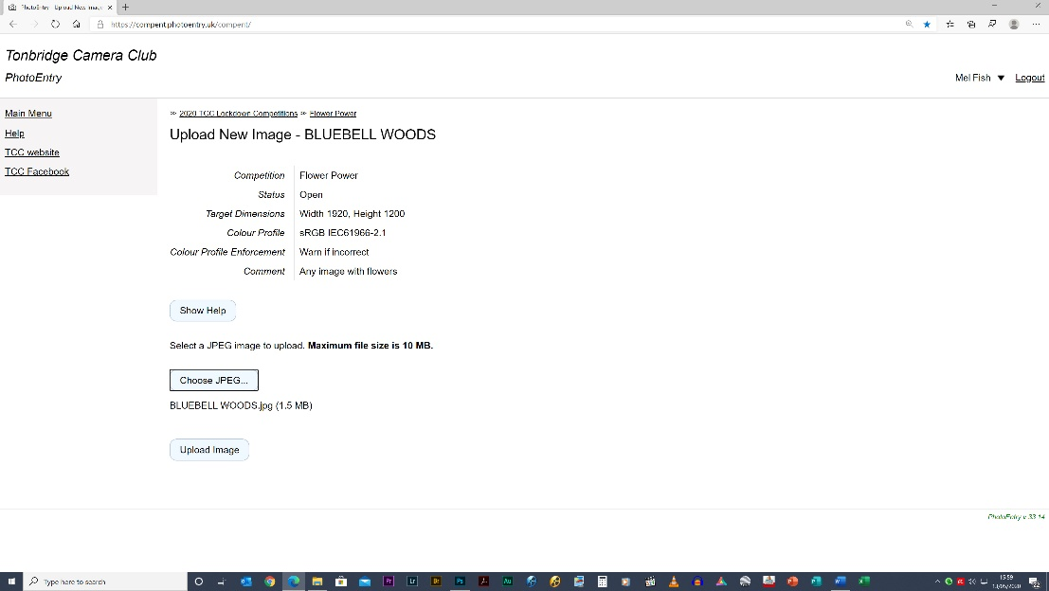
1 Click “Choose JPEG”, navigate to the correct folder and image and click “Open”.
2 The name appears below the “Choose JPEG…” box
3 Click “Upload Image”. The image will upload but this may take a few seconds (the status may appear at the bottom of your screen).
4 You will be warned of major errors. Check “Help” if you don’t understand it
Fig 08

This screen now appears.
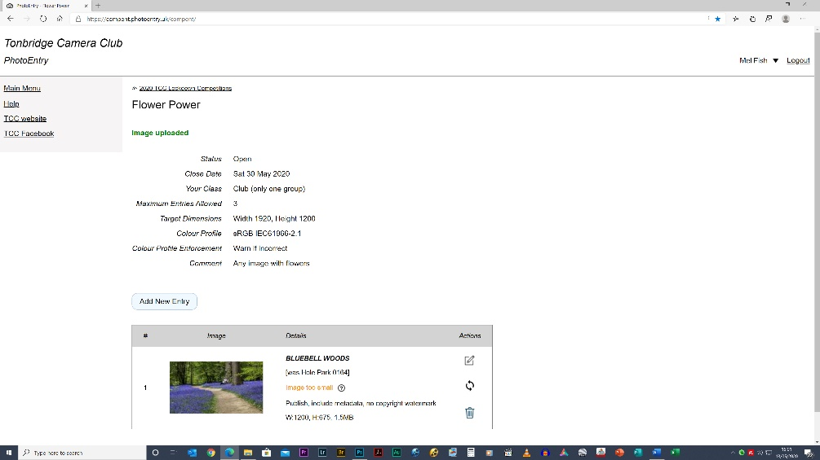

1 You will be warned of any problems – in this case, the image was too small but the software had not been configured to automatically reject it.
2 If you don’t understand an error message, check “Help” first before contacting the competition organiser.
3 You can investigate Actions here (e.g. deleting or renaming the image, rearranging the order, etc.)
4 You can add further images here up to the maximum allowed.
Fig 09

Finally, if you haven’t already done so, add the URL to your favourites: https://compent.photoentry.uk/compent/
Log Out when you’ve finished your session
See the next pages for important notes on resizing images:
Appendix 1: Do I need to resize images?

Always check the required dimensions shown on the image upload screen. They will almost invariably be 1920 x 1200.

- The projection software, DiCentra, requires images to be sized correctly, and has been known to display images in a less than desirable way if they are not.
- To be absolutely sure that your image is displayed in the best form, you should resize the image before uploading it (as described in the competition rules and in Appendices 2A and 2B). However, PhotoEntry will do an excellent job of resizing it (retaining the same aspect ratio) for you if necessary, although the best results will only be obtained if the uploaded image is substantially bigger than the required dimensions. For example, if 1920 x 1200 target dimensions are specified, submitting a 947 x 713 image will not yield a good result, but submitting a 3800 x 2100 (for example) image will be quite acceptable. Clicking on the thumbnail will show the resized image for you to check. Downsizing always gives better results than upsizing.
- A warning will be triggered if the target dimensions are not met. Depending on how the competition rules are configured, the software may reject your image and tell you to resubmit.
- A very common mistake is to resize for the long side. The size requirements specify a maximum width of 1920 and a maximum height of 1200. This is NOT the same as specifying a height of 1920 and a width of 1200.
- If the image is larger than 10MB, PhotoEntry will reject it.

Appendix 2A: A simple and free way to resize images online without using software
ALWAYS WORK ON A COPY OF THE ORIGINAL IMAGE

Go to: https://picresize.com/ (there are other similar sites)
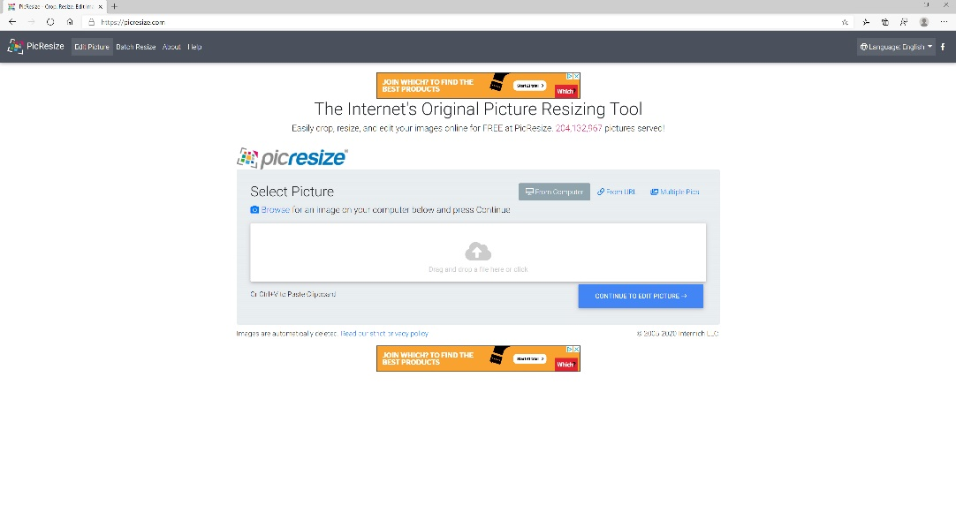
FIG 10
Drag an image here (or use the “From Computer” route) – this can be quite slow, depending on the size of the image. Then click “Continue to edit picture”
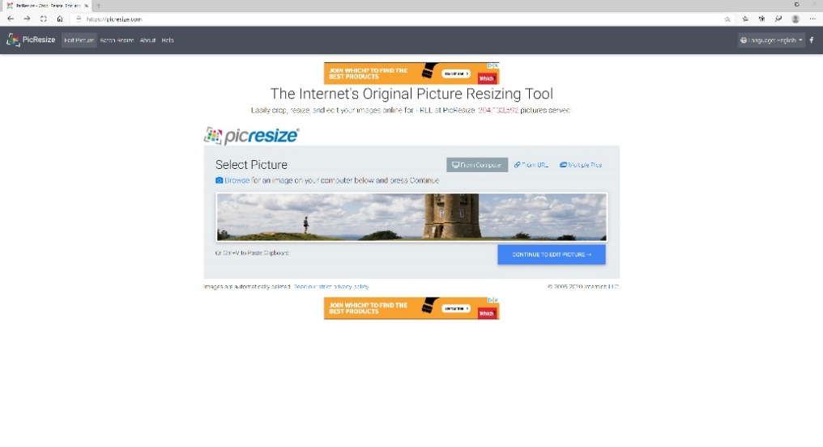
FIG 11
Click “Continue to edit picture. Don’t worry that only part of the image is visible.
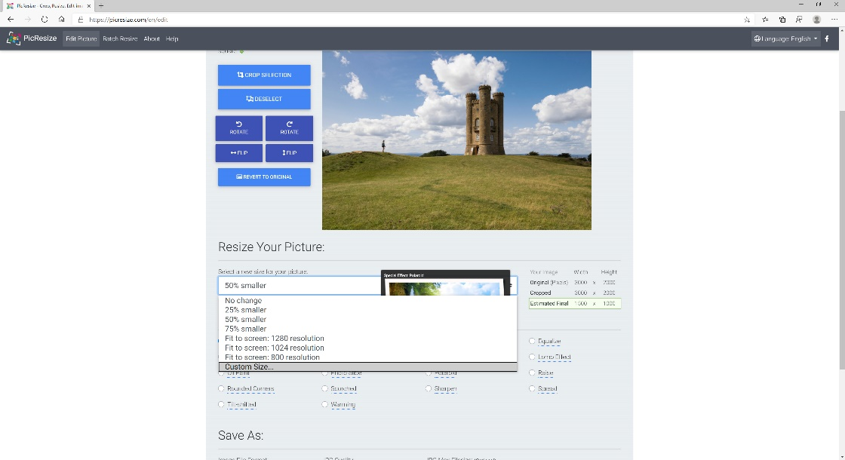
FIG 12
Click on “Resize Your Picture” and select “Custom Size” from the drop-down list
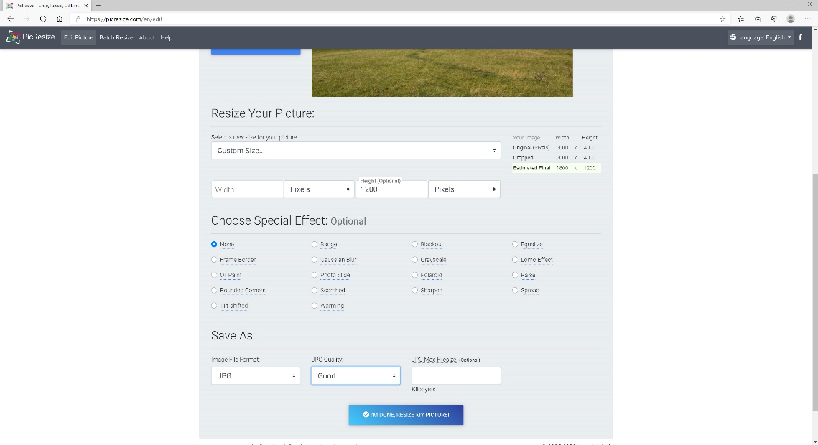
FIG 13
13.1 Type 1200 (pixels) in the Height Box. Click outside the box. If the “Estimated Value” now shows 1920 or more as width, go to 13.2. Otherwise go to 13.3.
13.2 Delete the “1200” and type 1920 in the Width box. The height in the “Estimated Value” box should now be 1200 or less. Go to the next stage (13.3).
13.3 Choose “Good”
13.4 Click “I’M DONE. RESIZE MY PICTURE”
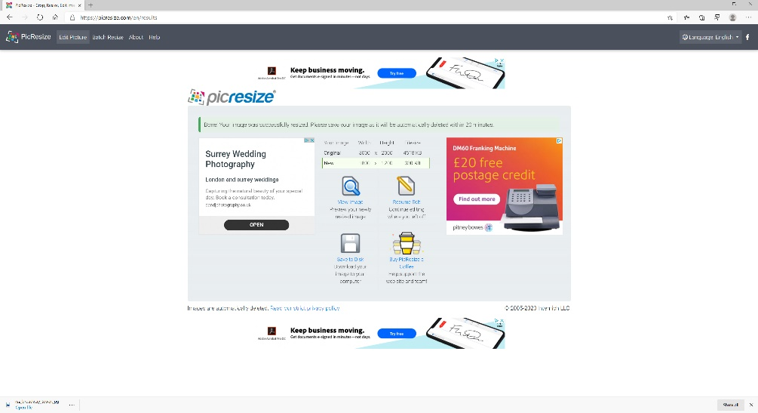
FIG 14
Choose “Save to disk”. The image will probably be saved by default in your “Downloads” folder.
Appendix 2B: A simple and free way to resize images using Microsoft’s “Photos” App.
ALWAYS WORK ON A COPY OF THE ORIGINAL IMAGE

Right click on the image and in the menu that appears click “Open With Photos”. See Fig 15
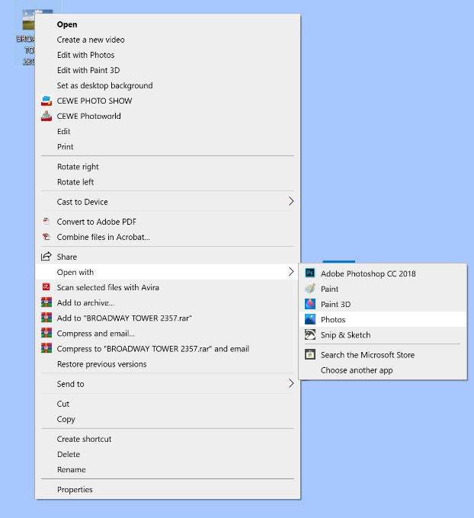
FIG 15

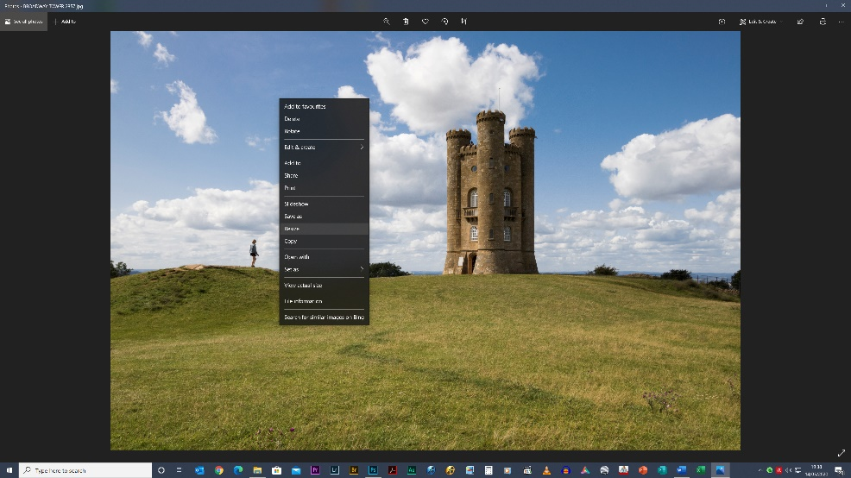
FIG 16
Right-click in the image and from the menu that appears, left-click on “Resize”
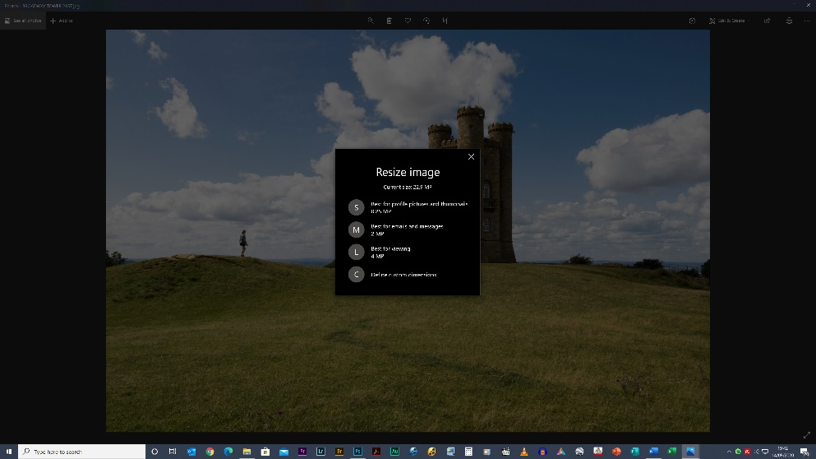
FIG 17
On the next menu, click “Define Custom Dimensions”
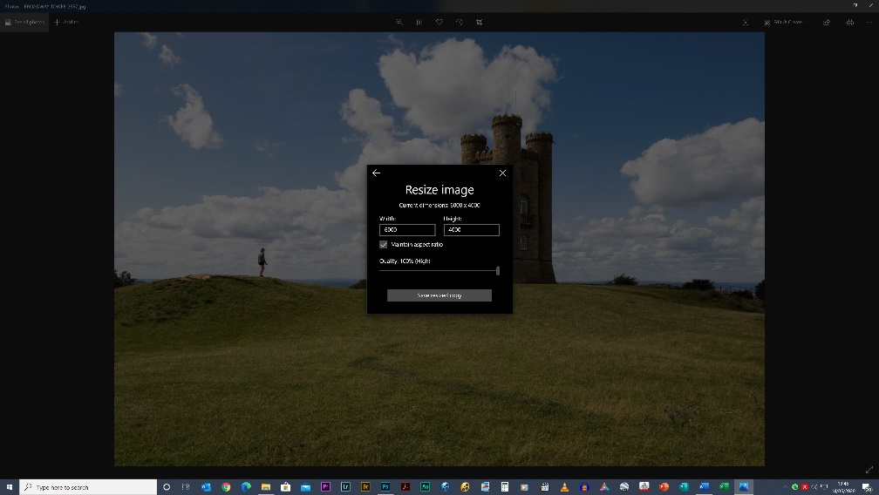
In the box that appears:
1 Tick Maintain aspect ratio
2 Set Quality to 100%
3 Replace the existing width value with 1900. If the height changes to 1200 or less, click “Save resized copy” BUT
4 If the height changes to 1201 or more, overwrite the height with 1200. The width will change to 1900 or less.
5 Click “Save resized copy”

FIG 18
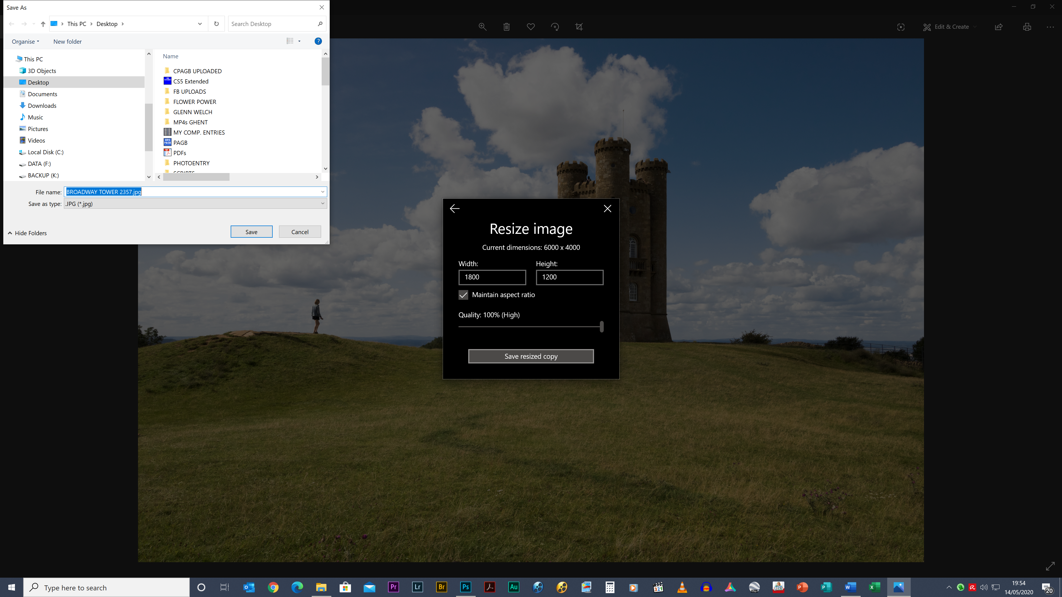
FIG 19
In the dialogue box that appears, decide where to save it. You’ll notice the new dimensions here.
EITHER the width will be exactly 1920 and the height 1200 or less
OR the height will be exactly 1200 and the width 1920 or less

